* + Iron Handicrafts

<https://exclusivelane.com/collections/wall-hangings/products/rajasthani-tribal-musicians-handmade-hand-painted-wall-hanging-in-iron-el-002-222?_pos=5&_fid=006ffb742&_ss=c>

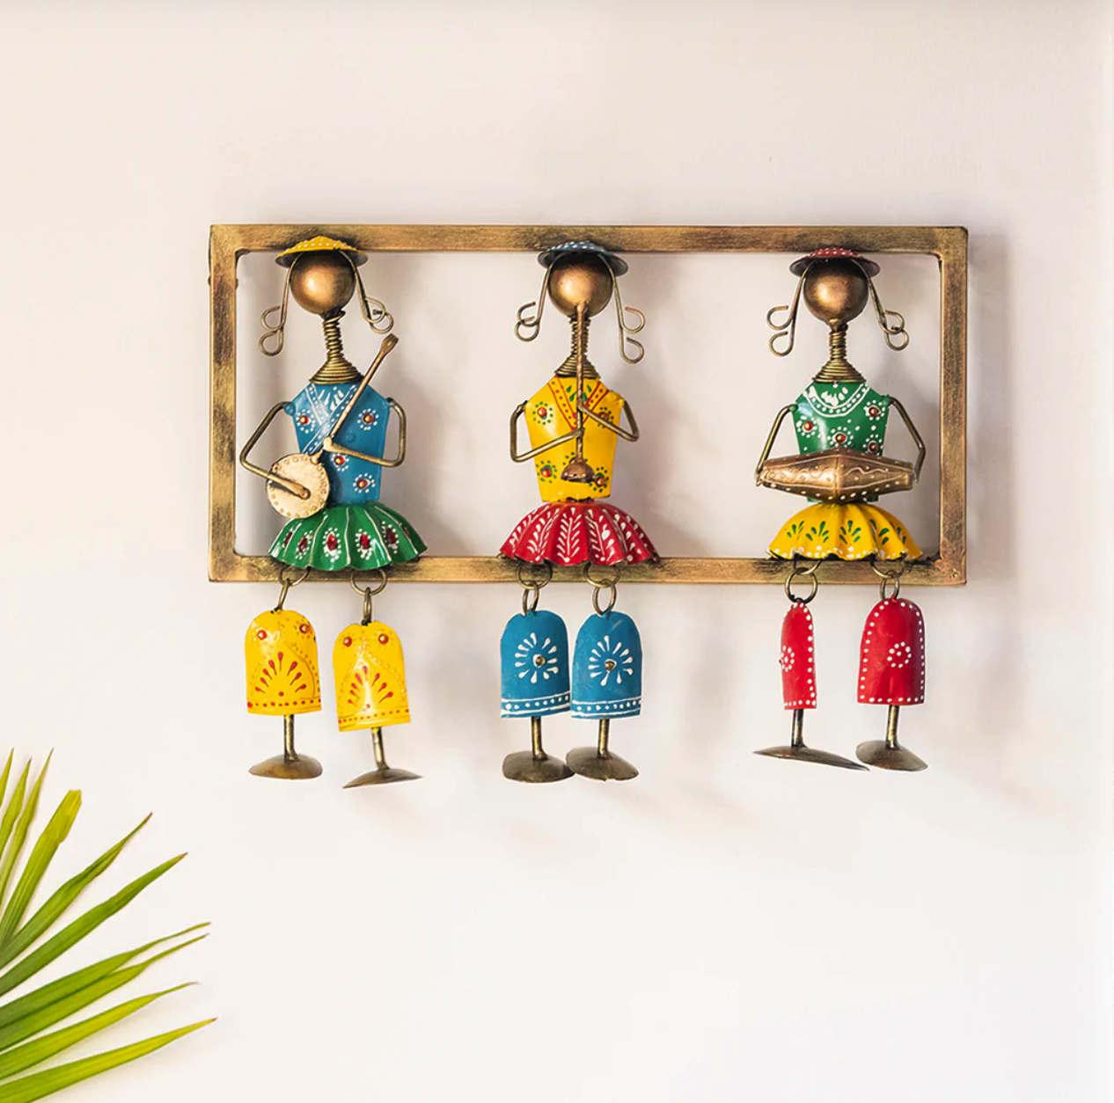

+ Glass Handicrafts

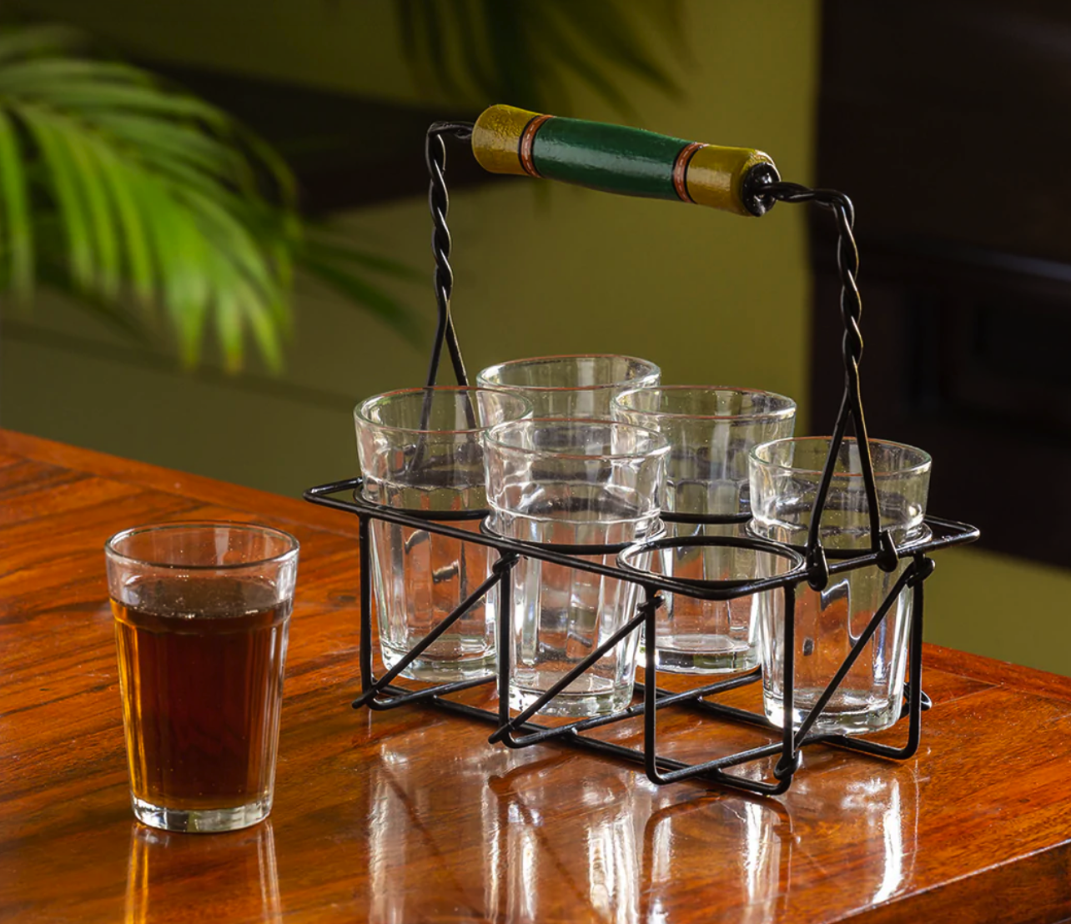

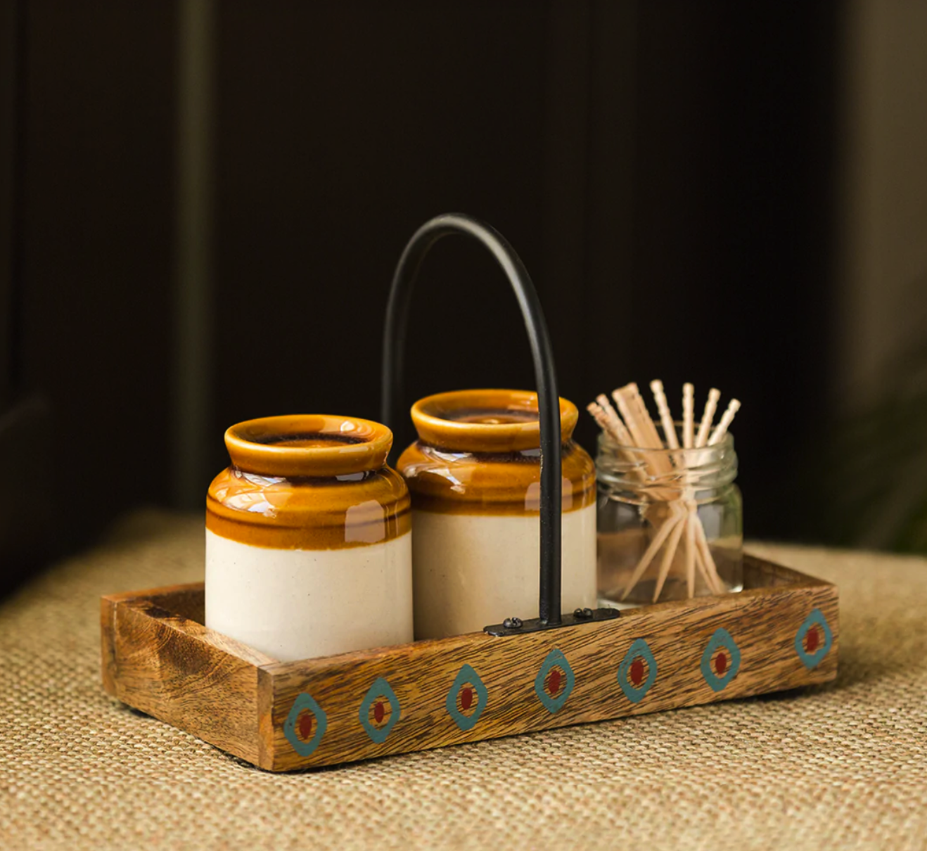

Brass Handicrafts

<https://exclusivelane.com/collections/all-kitchen-dining/products/floral-etched-handcrafted-spice-box-in-brass-with-spoon-7-containers-100-ml-el-005-958?_pos=1&_fid=3baf35277&_ss=c>

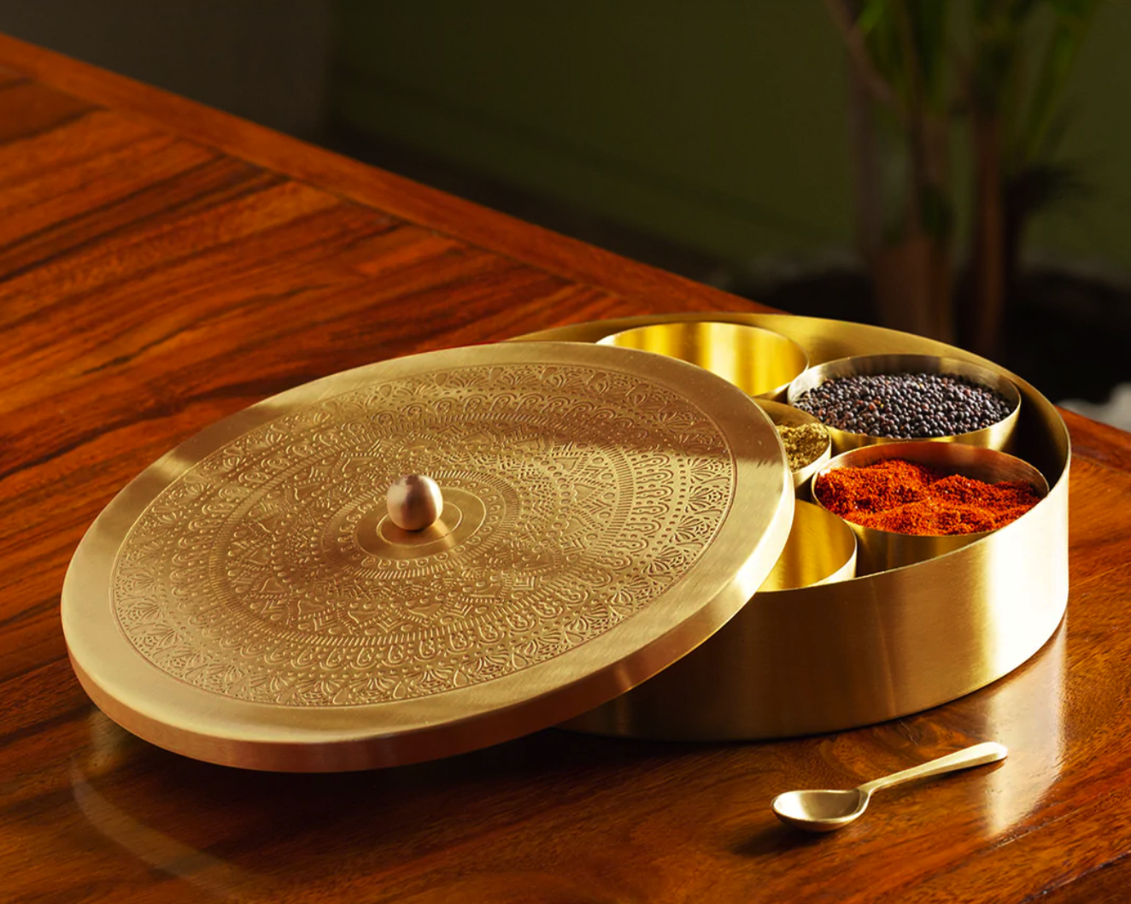

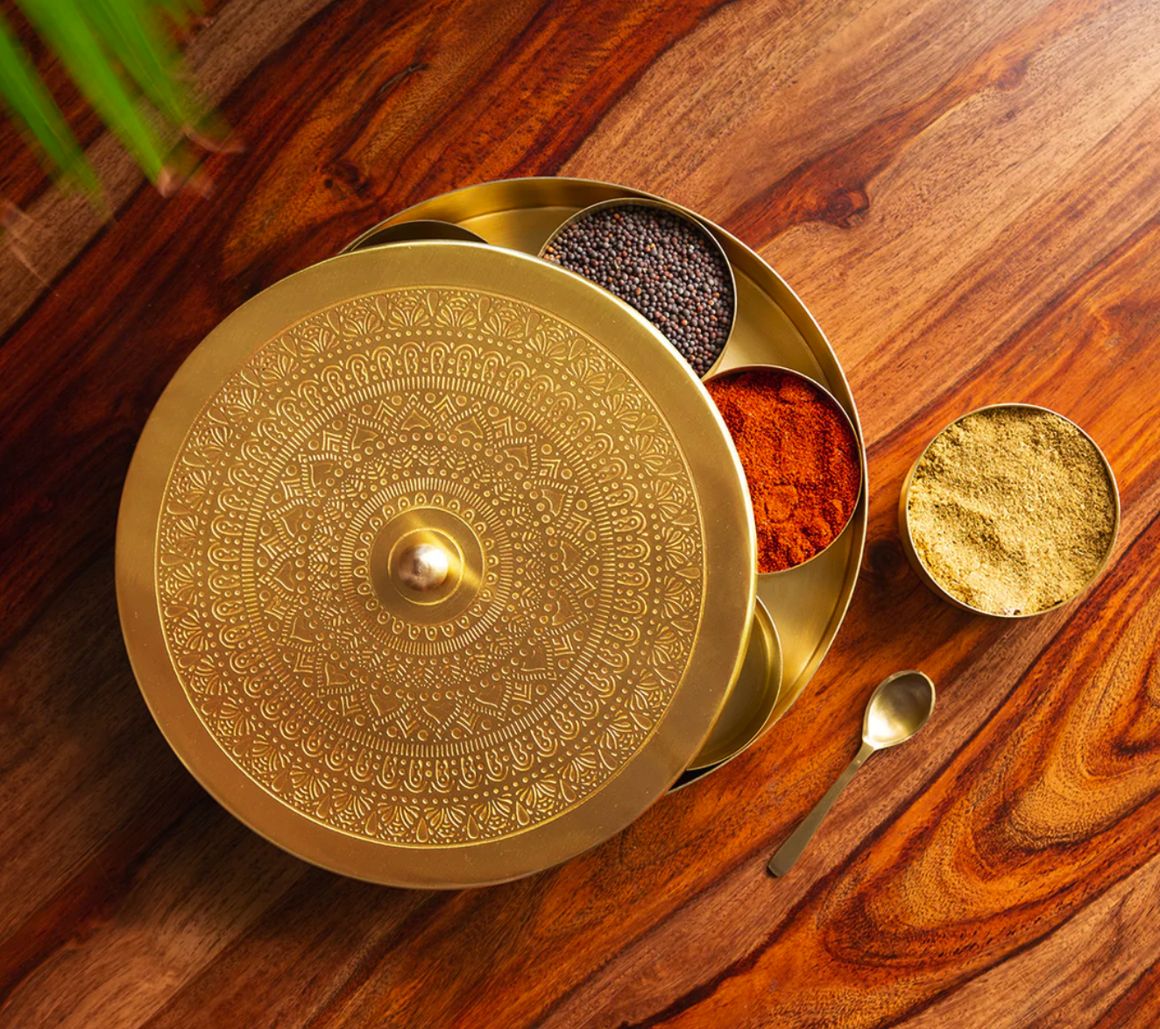

* + Wood Handicrafts

<https://exclusivelane.com/collections/all-kitchen-dining/products/the-elephant-warriors-hand-carved-spice-box-in-sheesham-wood-7-containers-el-005-772?_pos=10&_fid=17f8c9007&_ss=c>

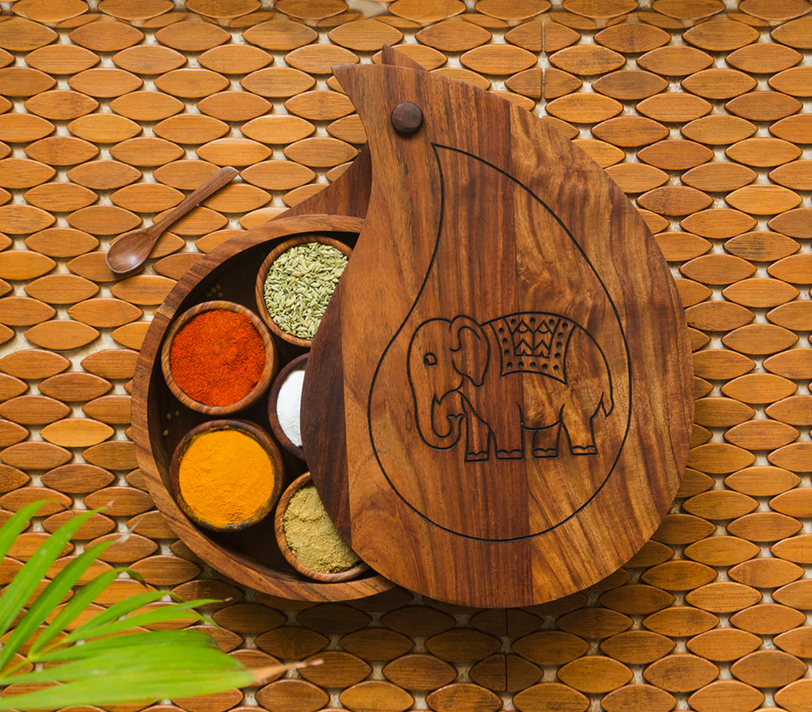

* + Aluminium Handicrafts:

<https://exclusivelane.com/products/the-blushing-flamingo-rustic-aluminium-wall-decor-wall-hook-8-7-inch-el-002-115?_pos=1&_psq=aluminium&_ss=e&_v=1.0>

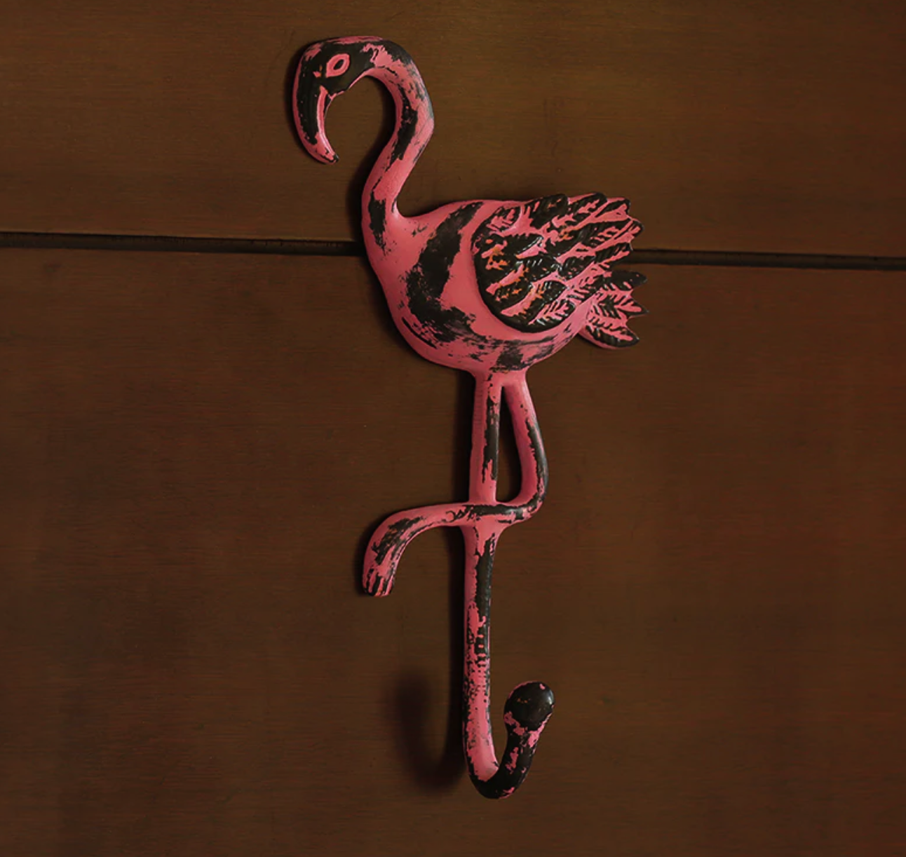

* + Handicraft Decorative

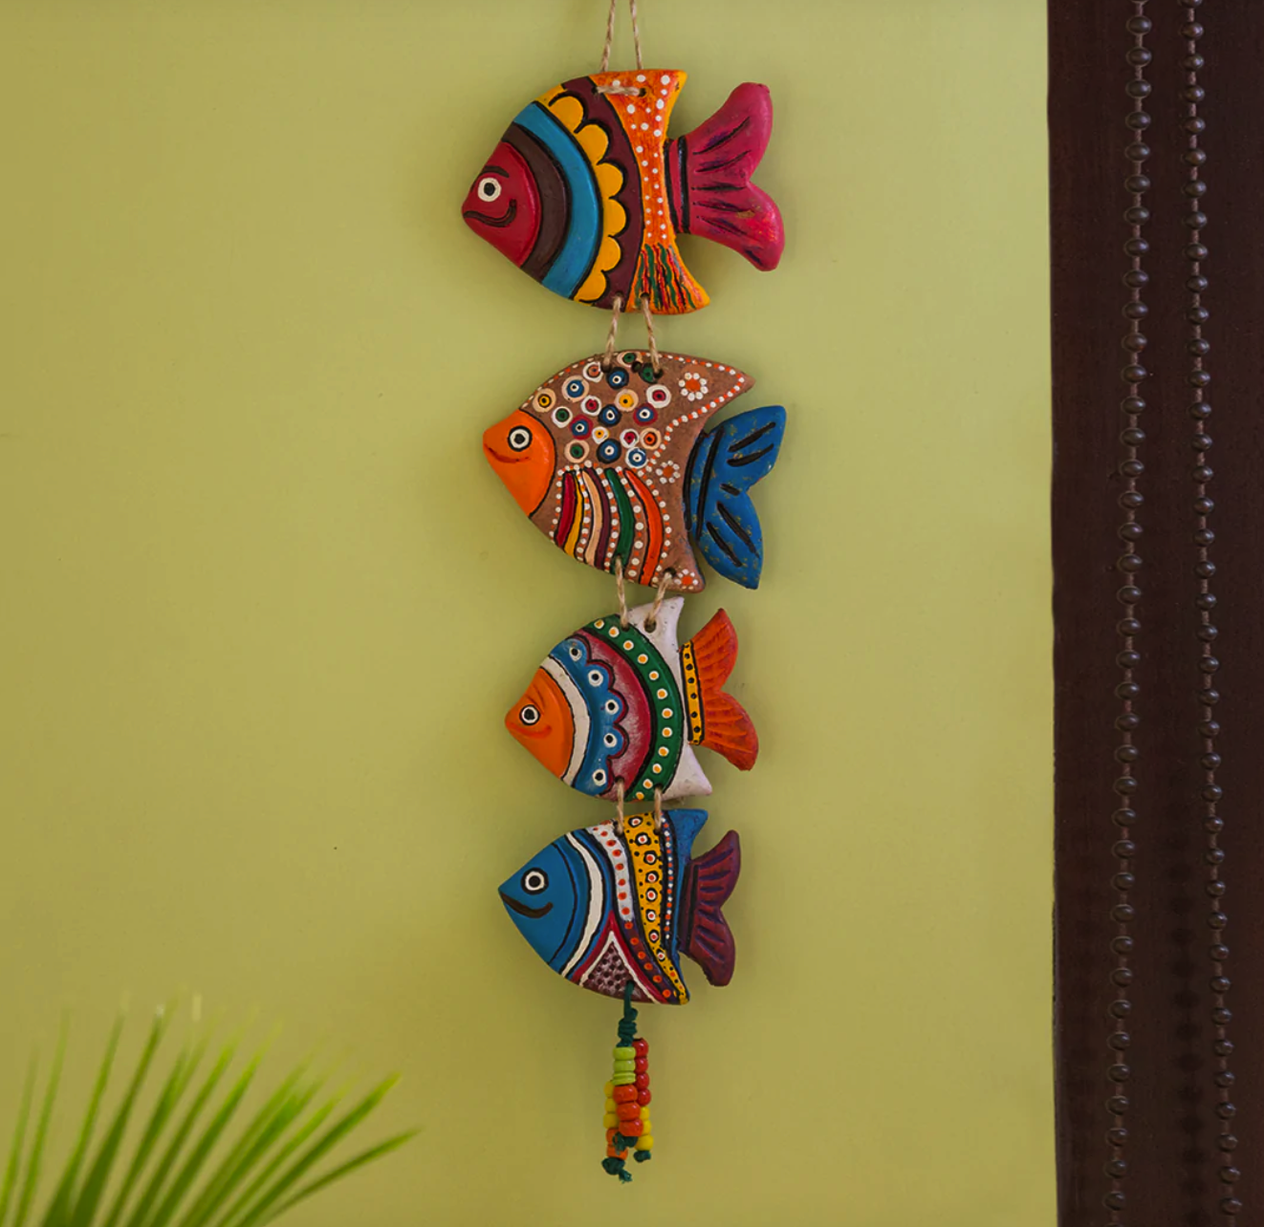

* + Tables wares:

<https://exclusivelane.com/products/bird-collection-wooden-table-organizer-el-007-031?_pos=1&_sid=56325bf1b&_ss=r>

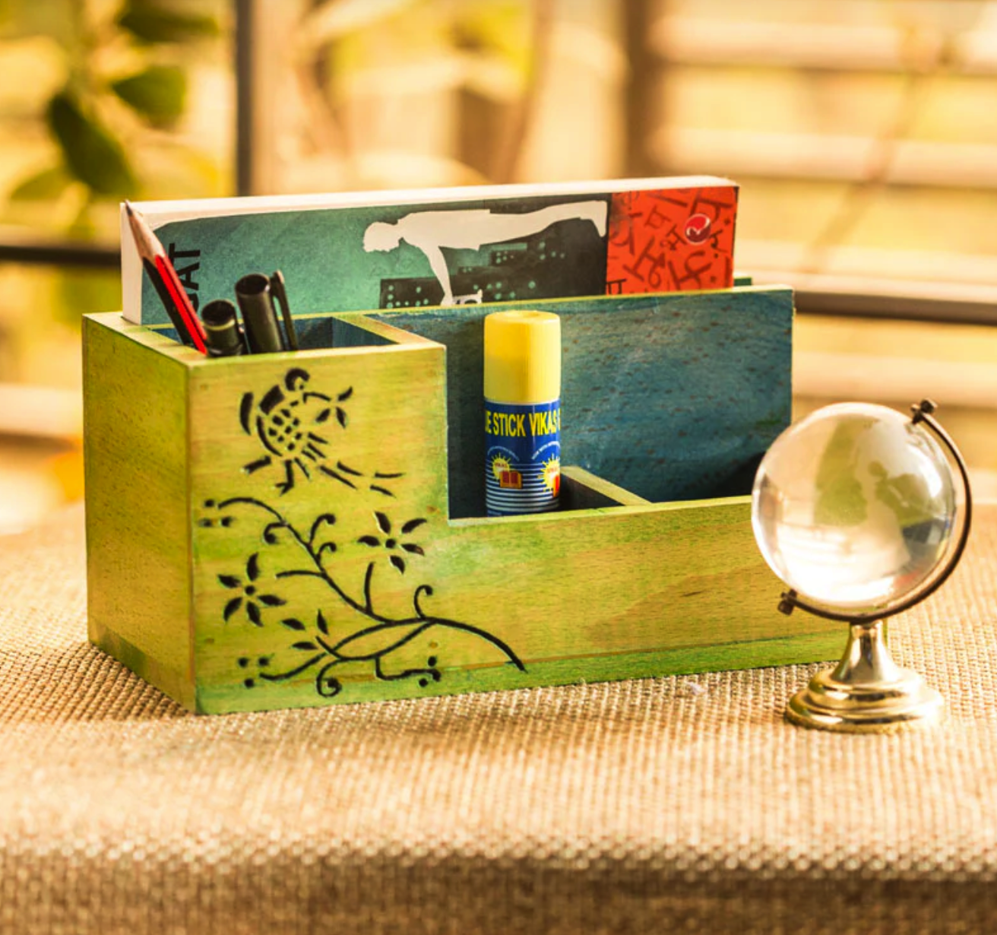

* + Home Décor:
* More

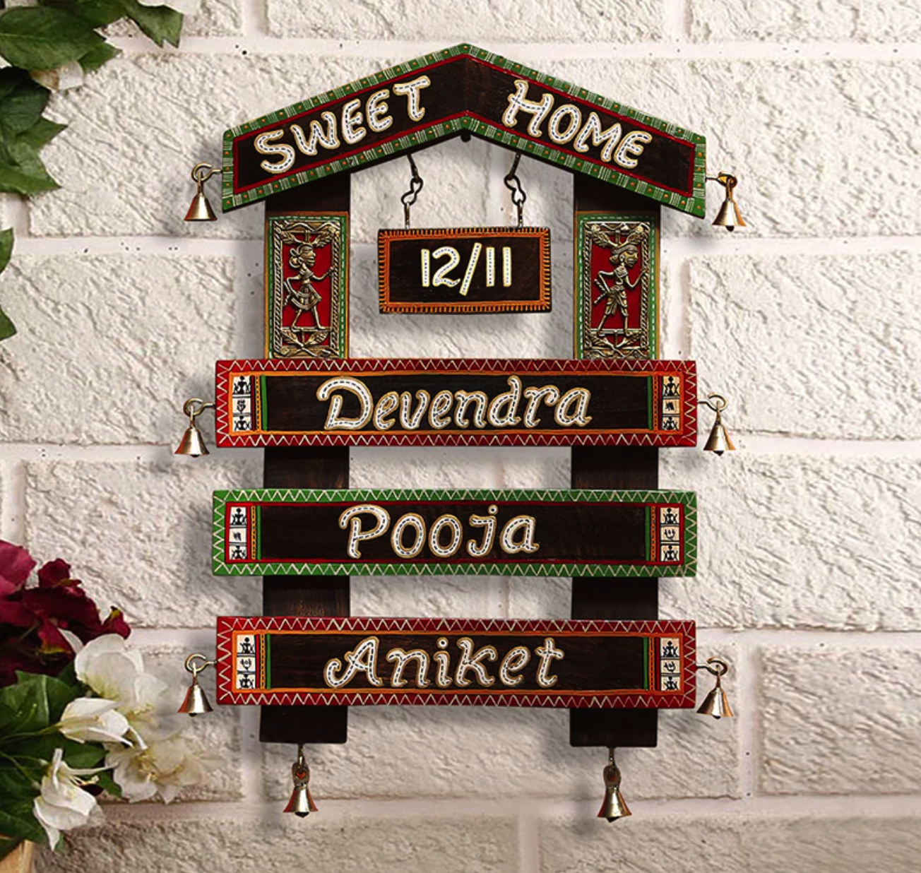

* + Candle Accessories

<https://exclusivelane.com/products/amber-teal-studio-pottery-candle-holder-in-ceramic-el-008-228?_pos=2&_sid=c2eacd022&_ss=r>

